Honouring Haringey’s First World War Conscientious Objectors
15 May is International Conscientious Objectors’ Day.
At 6pm on 15 May 2019 a plaque in honour of Haringey’s 350 Conscientious Objectors is being unveiled outside The Salisbury Hotel, Green Lanes, N4 1JX. On this very spot anti-war meetings took place in World War One. All are welcome at this event.
This week you will also find a special poster in 190 streets across Haringey – every street where a CO lived 100 years ago.
This brings to a close a centenary project by Haringey First World War Peace Forum, supported by a grant from the National Lottery Heritage Fund.
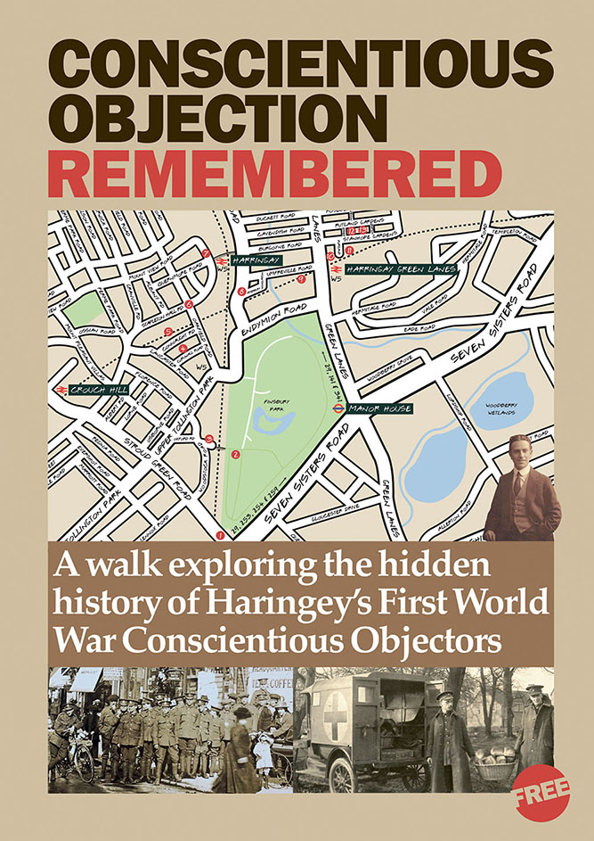
A local walk booklet telling the CO story is available from libraries. Ask us if you’d like a copy, or email us: HFWWPF@yahoo.com


See more on our website:
conscientiousobjectionremembered.wordpress.com
Honouring Haringey’s First World War Conscientious Objectors
15 May is International Conscientious Objectors’ Day.
At 6pm on 15 May 2019 a plaque in honour of Haringey’s 350 Conscientious Objectors is being unveiled outside The Salisbury Hotel, Green Lanes, N4 1JX. On this very spot anti-war meetings took place in World War One. All are welcome at this event.
This week you will also find a special poster in 190 streets across Haringey – every street where a CO lived 100 years ago.
This brings to a close a centenary project by Haringey First World War Peace Forum, supported by a grant from the National Lottery Heritage Fund.
A local walk booklet telling the CO story is available from libraries. Ask us if you’d like a copy or email us: HFWWPF@yahoo.com

See more on our website:
conscientiousobjectionremembered.wordpress.com

